New Spillway Weir
by Clarue Holland
[Weir: a low dam that is built across a river to raise the water level, divert the water, or control its flow. Background: Seepage under and through the old, badly eroded weir has been observed for many years now. The dropping of the lake level for the sewer project made it possible to repair the weir. Ed.]
Janet & Rich Hirsch, Rick Hannick, Gerry Arbini and Clarue Holland met with Don Eskridge of Reitz & Jens, Inc. on December 2, 2010, for the purpose of looking at the lake’s dam and spillway. We particularly needed to discuss the current spillway weir, which is leaking badly and sorely needs to be rebuilt or replaced.
Don Eskridge has been doing the engineering for any dam work done on our lake for some 25 years or so. He is very familiar with all aspects of our dam in addition to being familiar with Missouri State dam requirements and specifications and what work and/or changes would be needed should we be required to upgrade to a Class I dam from the current Class II certification that we hold. (A Class II dam is required when there are 1 to 9 dwellings or 1 campground, or 1 or more industrial buildings in the floodplain below the dam. Class I would be required when the number of dwellings or buildings are greater than in the Class II definition.)
The first item that was discussed after our tour of the dam and spillway was that, in Don’s expert opinion, we do not need to upgrade to the Class I status and will not need to do that for the foreseeable future. Don had compared aerial photos from a number of years prior to the more recent photos of April 2010 and found that there is no real increase in the dwellings below the dam that would be inundated by a flood from our lake. In fact, in the near future there will be a moratorium on even building in a floodplain. The new aerial photos should be completed in the next few weeks and new floodplain maps will be in force in the next year and a half.
Regardless of the above, we discussed totally re-doing the spillway so as to meet the Class I requirements. Don recommended installing a labyrinth (or serpentine) spillway weir as the best solution (rather than increasing the total height of the dam by quite a lot.) By installing a labyrinth weir, lowering the spillway channel downstream from the weir and cutting out the flat spot (in the channel), we would then have the capability of handling a major storm (21 inches of rain in 6 hours). This could cost about $337,000. Raising the dam would cost approximately $285,000. These are rather rough estimates, but are ones that Don did some research to put together for us.
Our dam is well within the specifications for the Class II requirements. In fact, we meet a couple of the required specifications for a Class I dam.
Not needing any changes to fit the Class I specifications, we discussed proceeding to correct the leaking weir. We must tear out the existing weir and rebuild at the current site. The height must remain at the same measurement. If not, rebuilding would require a permit from the Department of Natural Resources (DNR). By not changing the height, the rebuilding is considered to be simply maintenance. We need to be very particular on the rebuilding for this reason alone.
Don submitted his complete report and specifications for rebuilding the spillway weir. He also included where the sewer lateral piping should be placed and how it should be run. That piping should be placed on the spillway side of the weir (rather than the lake side). No piping should run through the dam lakeside of the weir and below the water level as that that would result in an easy conduit for future leaking. The Board of Directors gave us the authorization to proceed and to seek bids on rebuilding the spillway weir according to the specifications.
Three companies submitted bids for the project::
Oreo & Botta Concrete Co $34,250
Waddell Concrete $20,750
Holloran Contracting $14,490
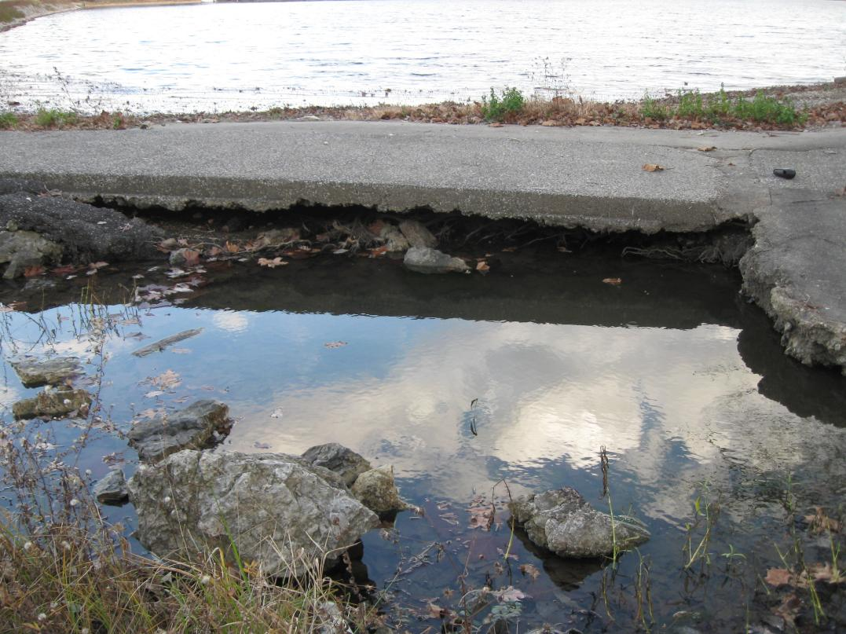
Holloran Contracting was awarded the contract for the job. Construction began February 9 and was completed February 16.

